**Full Stack Web Development**

* **Web Application**
* **Distributed Application**
* **Mobile Native Application**
* **SPA [Single Page Application Architecture]**
* **Progressive Web Application Architecture**

**Web Applications**

**What is a Network?**

* A computer network comprises group of computers connecting with each other for sharing of information and resources.
* The first computer network was “ARPANET” [Advanced Research Projects Agency Network] introduced by US-Department of Defence.
* CERN Labs [Council for European Research and Nuclear] introduced a network for general and commercial purpose.
* Internet evolved [It is a network of computer connecting all over the world].
* Internet is not secured, there is no restriction.
* “**Tim Berners Lee”** introduced the concept of **Web** in early 1990’s.

**What is Web?**

* Web is a portion of Internet with restricted access.
* Tim Berners Lee introduced **Web**.
* Web Application will have restricted access.
* Web Standards are maintained by “W3C and WHATWG” groups.
* W3C – World Wide Web Consortium
* WHATWG – Web Hyper Text Application Technology Work Group.

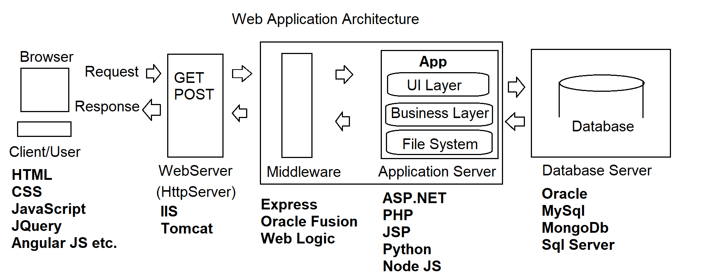

**What are the basic requirements for building End-to-End Web Application?**

* HTML
* CSS
* Client-Side Script
* Server-Side Script
* Database
* Middleware
* Desktop Publishing Tools
* IDE’s [Integrated Development Environment]

|  |  |
| --- | --- |
| **Language / Tool / Technology** | **Purpose** |
| HTML | It is a mark up language.  It is used for presentation.  **HTML 5 [HTML 4 and HTML 5]** |
| CSS | It is used to make presentation more interactive and responsive.  **CSS 3 & CSS 4**  **Bootstrap 4.5** |
| Client-Side Script | It is uses to reduce the burden on server.  It handles client-side interactions and validations.  Ex:  Language **– JavaScript [ES6]**, TypeScript etc.  Library – **Jquery [3.5]**, RxJS, Jqlite etc.  Framework – **Angular JS [1.9]**, Backbone, Knockout JS etc. |
| Server-Side Script | It is script that runs on server.  It generates a response customized for every client request.  Ex:  ASP.NET  PHP  JSP  Python  **Node JS [12x]** |
| Middleware | It is a software framework.  It handles the communication between servers in network application.   * Parsing the data * Serving Static Files * CORS [Cross Origin Resource Sharing] etc.   Ex:  Oracle Fusion  **Express [4x]**  Web Sphere etc. |
| Database | It handles the data required for application.  Ex:  **MySql**  **MongoDb**  Sql Server  Oracle |
| DTP Tools | These tools are used to publish images and animations for web.   * **Photoshop** * CorelDraw * Illustrator * **Flash** |
| IDE | Integrated Development Environment   * Build * Debug * Test * Deploy   Ex:  Visual Studio  **VS Code**  Sublime  Web Strom  Eclipse etc. |

**Full Stack**

* **Web Application Development**
  + HTML
  + CSS
  + JavaScript
  + Jquery
  + Angular JS
  + Node JS
  + Express
  + MongoDb
  + MySql
  + Visual Studio Code
  + Photoshop
  + Flash
* **Distributed Applications**
* **Mobile Native Applications**